Warehouse Assistant
40 hours per week
Reports to: Warehouse Manager
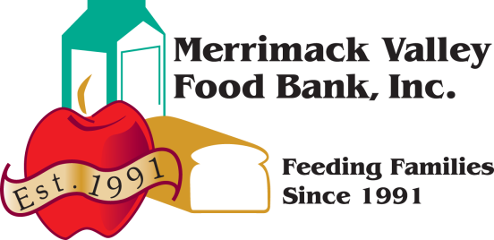
Available immediately
Salary Range: $15.00 to $18.00 per hour
Please email resume to tluna@mvfb.org.
The Merrimack Valley Food Bank is an independent, non-profit organization with a mission to provide adequate nutrition and freedom from hunger. The MVFB currently serves feeding programs in over 50 cities and towns in Massachusetts and southern New Hampshire.
MVFB is looking for a Warehouse Assistant to join our team. Candidates must be organized, friendly, courteous, and dependable.
Under the direction of our Warehouse Manager your responsibilities will include but not be limited to:
- Assisting Warehouse Manager with our Community Market and Food Rescue programs
- Transporting food donations in a box truck with air brakes
- Safely Receive, distribute and rotate food inventory in our warehouse
- Interact with our member agencies, volunteers, and visitors to the food bank
- Maintain a clean and safe working environment
- Assist Warehouse Manager with monthly inventory
- Ability to take the initiative and make positive suggestions to improve warehouse processes
- Works well with other team members
Requirements
- Must be at least 18 years old
- Valid driver’s license and excellent driving record
- Must pass DOT physical exam, drug and alcohol test
- Able to lift 50lbs and stand for 30 minutes at a time
- Access to reliable transportation to and from work
- Electric fork truck and pallet jack experience is a plus
- Must be able to read and write, add and subtract
- Basic knowledge of, and some experience in, standard warehousing practices and procedures.
- Basic computer skills including working knowledge of Microsoft Word, Excel, and Email
- Being able to work overtime when asked, sometimes on short notice, responding to 'mandatory' overtime requirements when needed and an occasional weekend.
The policy and intent of the MVFB is to provide equal employment opportunity for all persons regardless of race, color, religion, national origin, marital status, political affiliation, affectional orientation or gender identity, status with regard to public assistance, disability, sex, or age. The MVFB intends to respond affirmatively in its employment practices. Affirmative action applies to all aspects of employment practices including, but not limited to, recruiting, hiring, placement, promotion, transfer, training, compensation, benefits, layoff, recall, and termination. The MVFB seeks to do business with Agencies and Donors that encourage equal employment opportunity.

