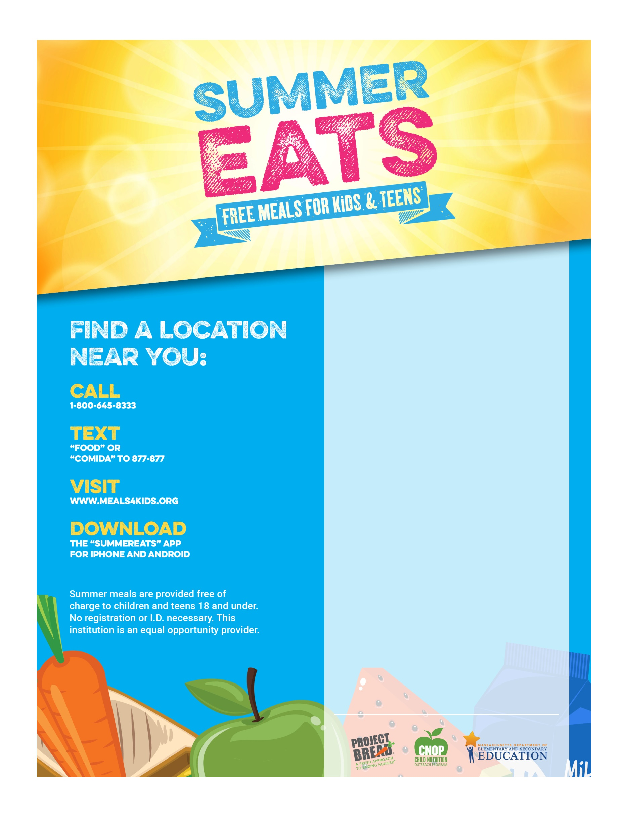

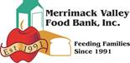

**July 6th - August 14, 2020!!**

**Open Meal sites listed below!!**

**Caleb Group 77 Chestnut St.**   
**(L) 11:15 - 12:00 (S) 2:15-2:35 Mon-Thurs.**  
  
**Eagle Park 95 W. 6th St.**   
**(L) 11:15-11:45 Mon - Fri**  
   
**McPherson Pool 1000 Bridge St.**   
**(L) 12:15 -1:00 Mon - Fri**   
   
**North Canal Apartments 517 Moody St**. **(L) 12:15 -12:45 T-Thur.**  
**O’Donnell Splash Pad 1170 Gorham St.**   
(**L) 1:30 -2:00 Mon -Fri**

**This Institution is an equal opportunity provider.**