Material Handler/Order Picker
Part-Time Monday-Thursday 11:00-3:30
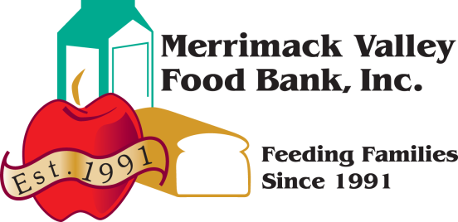
Available immediately - $16.50-$17.50 per hour
Please email resume to Tammie Dubois at tdubois@mvfb.org
The Merrimack Valley Food Bank is an independent, non-profit organization with a mission to provide adequate nutrition and freedom from hunger. The MVFB currently serves feeding programs in over 50 cities and towns in Massachusetts and southern New Hampshire.
MVFB is looking for a Warehouse Associate to join our team in a fast paced and busy environment. Candidates must be organized, friendly, courteous, and dependable. Must pass a basic reading and math assessment, and be able to read and understand English.
- Accurately select and pick orders and hand build mixed product pallets for the feeding programs
we serve. Wrapping pallet when complete and staging it for pick-up
- Safely Receive, distribute and rotate food inventory in our warehouse
- Interact with our member agencies, volunteers, and visitors to the food bank
- Maintain a clean and safe working environment
- Assist with monthly inventory count
- Ability to take the initiative and make positive suggestions to improve warehouse processes
- Work well in a team environment
Requirements
- Must be at least 18 years old
- High school diploma or equivalent
- Pass a basic reading and math assessment test
- Must be able to read and understand English – Bilingual a plus
- Capable of lifting 50-60 pounds repeatedly during a shift and able to stand for long periods of time
- Access to reliable transportation to and from work
- Electric fork truck and pallet jack experience is a plus
- Experience in, standard warehousing practices and procedures.
- Keen attention to detail, self-motivated, positive attitude, excellent communication skills
- Basic computer skills including working knowledge of Microsoft Word, Excel, and Email
- Able to work overtime when asked, sometimes on short notice, responding to 'mandatory' overtime requirements when needed and an occasional weekend.
We strive to make the Merrimack Valley Food Bank a great place to work. Eligible employees are offered a variety of benefits including medical insurance, paid holidays, vacation and sick time.
The policy and intent of the MVFB is to provide equal employment opportunity for all persons regardless of race, color, religion, national origin, marital status, political affiliation, affectional orientation or gender identity, status with regard to public assistance, disability, sex, or age. The MVFB intends to respond affirmatively in its employment practices. Affirmative action applies to all aspects of employment practices including, but not limited to, recruiting, hiring, placement, promotion, transfer, training, compensation, benefits, layoff, recall, and termination. The MVFB seeks to do business with Agencies and Donors that encourage equal employment opportunity.

